Bridgemere CE Primary School
Autumn Term 1 Newsletter
Year 3/4 – Mr Lyons

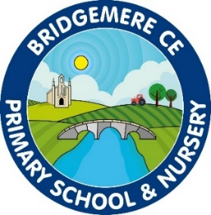

Dear Parents/ Carers,
Welcome back to another year in Bridgemere CE Primary School & Nursery. We hope you had an enjoyable summer break and are ready for the new academic year ahead!

This is an exciting year for all and I am looking forward to working with all the children in Year 3/4 and watching them flourish throughout the year.
Mr Lyons will be teaching class 3 and Mrs Smart will be teaching art and DT to the class on a Tuesday afternoon. We have also got Miss Wilkinson who will be in Class 3 supporting the children.

Curriculum
This half term we will be developing our knowledge of the theme ‘World Awareness’ by exploring our topic ‘A Passport to Europe’. The children will be learning about the countries that are in Europe and expressing what they think makes Great Britain great. We will then discover what is fantastic about France and contrast our findings. Our Art and DT will also link to our topic as we explore and create different famous landmarks in Europe.

Reading
Your child will need their communication diary in school every day. It is important that children are reading every night for at least 15-20 minutes. Reading is a key skill, which has a huge impact on all areas of the curriculum. Children need to record what they have read in their communication dairy – which will be checked daily.

Once your child has finished a book they will complete the Accelerated Reading Test online at school. This is a comprehension test that assesses how well they have understood their book.

Homework
Homework will consist of the following:
- Reading
- Spellings (that will be linked to a spelling rule, children are to learn the rule and apply it successfully to similar words) OR
High Frequency words – there may be words that your child is still misspelling during independent writing that need to be revised
- TimesTables rockstars. Children will receive their logins shortly.

P.E
PE will now take place on a Monday afternoon and Wednesday afternoon.
The children will be doing lots of different activities in PE and this half term we will be looking at both football and tag rugby. Please can your child have both their named inside and outside kits in school at all times. Children will be doing daily active 15minutes and will need their trainers in school at all times.
I am really looking forward to this term and hope that your child is too. If you have any concerns or questions about your child’s learning, please book an appointment to speak to me through the school office or use the communications diaries that are checked each morning.

Thank you for your support and I look forward to another successful year with Bridgemere.
Mr Lyons.

