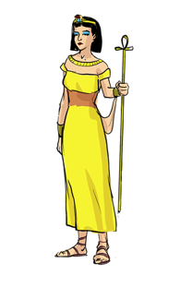
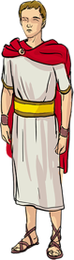
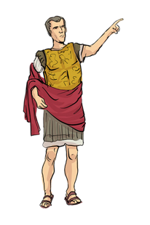
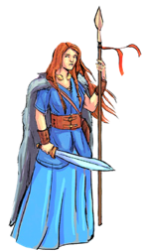
Y3/4 – The Romans

How did the Roman Empire impact Britain?
Previous Learning

This unit looks at the Romans and their achievements from 43 CE to 410 CE. The first lessons explore what life was like in early Rome, who was in charge and held the power across the Empire and how the emperors trained up their powerful armies. This moves onto the Roman invasion of Britain; a comparison between the existing Celtic villages and the new Roman settlements, alongside finding out how the Romans protected their new lands and an introduction to significant historical figures of the time such as Boudicca. The unit finishes with a study of the final years of the Roman Empire and the events led to its downfall.

Year 1/2 – Children will have developed a strong basis of using historical disciplines such as chronology, similarity and difference, cause and consequence and handling historical artefacts. They understand that there is a past within their living memory and a past beyond that. Substantive concepts such as trade, industry and settlement will have been mentioned but not explicitly taught. Children will have a basic understanding of monarchy from the unit ‘Castles, kings and queens’.
Year 3 – Children will have a clear chronological understanding of Ancient Britain. They will know that the Celts lived in round houses and developed strong defensive systems called hill forts. Children will know how we find out about prehistory and know how to use sources to inform their historical interpretations.
Year 4 – Children will know about Greek culture and see how they influenced Roman culture.
Overview Of Learning

Year 5 – Children will go on to study the ancient culture of the Maya.

Year 6 – Children will find out how the Romans punished criminals in their topic of ‘Crime and Punishment’.

KS3 – Children will use key sources of information and evaluate their reliability. They will continue to ask questions of enquiry and have an established understanding of key substantive concepts
Future Learning
Knowledge And Understanding Objectives

Pupils should continue to develop a chronologically secure knowledge and understanding of British, local and world history, establishing clear narratives within and across the periods they study. They should note connections, contrasts and trends over time and develop the appropriate use of historical terms. They should regularly address and sometimes devise historically valid questions about change, cause, similarity and difference, and significance. They should construct informed responses that involve thoughtful selection and organisation of relevant historical information. They should understand how our knowledge of the past is constructed from a range of sources. In planning to ensure the progression described above through teaching the British, local and world history outlined below, teachers should combine overview and depth studies to help pupils understand both the long arc of development and the complexity of specific aspects of the content. Pupils should be taught about:
the Roman Empire and its impact on Britain
Key Vocabulary To Explain
Working Scientifically Objectives

Exploration and Invasion
Power

Substantive concepts explicitly taught:
civilisation, trade, settlement, empire, monarchy, rebellion

archer, infantry, fleet, annex, military alliance, legion, emperor, empire, peninsula, tactic, settlement, kingdom, revolt, occupation, outnumber, governor, conquer, fort, defences, civil war, pillage.

Words in bold relate to the themes, concepts and skills that run throughout the whole history curriculum. Children will need to know the meanings of these words and have examples of them in context. These concepts will be built upon throughout the rest of the history curriculum.
Misconceptions

Children may believe that Julius Caesar was the first emperor of Rome because he made attempts to invade Britain earlier, however Augustus was the first Roman emperor. Children may think that the Roman Empire was just modern day Italy and then it expanded to include Britain. Children may think that the Romans got rid of the celts, when in actual fact there was a blending of cultures and a distinct Romano-Celtic culture was created.
www.grammarsaurus.co.uk

Unit Overview

How did the Roman Empire impact Britain?
How did early Rome grow to become the Roman Empire? |  |  | How did the Britons resist occupation? |  |  | How did the Roman maintain control over Britain?
Lesson 1 | Lesson 2 | Lesson 3 | Lesson 4 | Lesson 5 | Lesson 6 | Lesson 7 | Lesson 8
Key question:  What do we know about early Rome & how do we know this? | Key question:  Who was in charge of the Roman Empire | Key question:  How powerful was the Roman army? | Key question:  What events led up to Emperor Claudius invading Britain? | Key question:  How did the Roman settlements compare to the Celtic villages? | Key question:  Who was Boudicca and why did she take revenge on the Romans? | Key question:  How did the Romans protect their land and do we know this? | Key question:  What happened in the final years of the Roman Empire?
Historical Skill:  Evidence and Interpretation | Historical Skill:  Chronology | Historical Skill:  Historical Significance | Historical Skill:  Chronology | Historical Skill:  Similarity and Difference | Historical Skill:  Cause and consequence | Historical Skill:  Evidence and Interpretation | Historical Skill:  Change and Continuity
Substantive concepts build on:  civilisation, settlement, empire, monarchy |  |  | Substantive concepts build on:  civilisation, trade, settlement, rebellion |  |  | Substantive concepts build on:  civilisation, settlement, empire, monarchy
Cumulative quiz:  Q1 - Q3 | Cumulative quiz:  Q4 - Q6 | Cumulative quiz:  Q7 - Q9 | Cumulative quiz:  Q10 - Q12 | Cumulative quiz:  Q13 - Q15 | Cumulative quiz:  Q16 - Q19 | Cumulative quiz:  Q20 - Q22 | Cumulative quiz:  Q23 - Q25
www.grammarsaurus.co.uk
Assessment
Stretch and Challenge ideas across the unit

- The knowledge organiser can be used to support children. This could be on display, on the tables, sent home or used for pre-teaching key vocabulary or concepts.

- The post-unit test can be used to assess the knowledge and understanding objectives taught throughout the unit. This can be done independently or in small groups with a teacher.

- There is a cumulative quiz with questions that can be used to assess children throughout the topic. The quiz questions will link directly to each objective. They can also be used at the end of each lesson to give immediate feedback to inform future planning and give the opportunity to identify children who do not understand.

Children could:
- Reason about the reliability of sources presented to them.
- Compare sources and evaluate them, coming up with their own historical interpretation.
- Compare different periods in time and say what is the same and what is different.
- Study archeological evidence and create historical interpretations, based upon the knowledge they have learned.
- Consider how the future might be impacted by the events of the past.
- Make statements which are justified by historical evidence.
- Find out about who the Druids were and why the Romans made a huge effort to get rid of them.
- Discover a blending of Roman and Celtic religions and gods.

