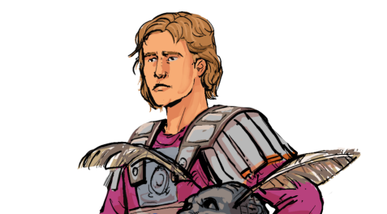
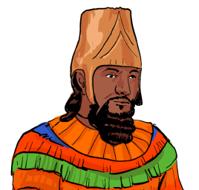
Knowledge and Understanding Objectives
Future Learning
Misconceptions

Children will need a sound understanding of the dating system BCE (Before Common Era) before they begin this unit. It will need to be taught explicitly. As this may confuse the children when faced with dates such as 352 BCE and 323 BCE. Children may think 352 BCE is later in time. They will need to be corrected and frequent looks at a historical timelines will help this.
Year 5 – Children will describe causes of events and their consequences in Ancient Maya. Children will also compare the similarities and differences between civilisations and cultures.
Year 6 – Children will describe the characteristic features of the past, including ideas, beliefs, attitudes and experiences of men, women and children. Children will describe the social, ethnic, cultural or religious diversity of past society.

KS3 – Children will use key sources of information and evaluate their reliability. They will continue to ask questions of enquiry and have an established understanding of key substantive concepts

Pupils should continue to develop a chronologically secure knowledge and understanding of British, local and world history, establishing clear narratives within and across the periods they study. They should note connections, contrasts and trends over time and develop the appropriate use of historical terms. They should regularly address and sometimes devise historically valid questions about change, cause, similarity and difference, and significance. They should construct informed responses that involve thoughtful selection and organisation of relevant historical information. They should understand how our knowledge of the past is constructed from a range of sources. In planning to ensure the progression described above through teaching the British, local and world history outlined below, teachers should combine overview and depth studies to help pupils understand both the long arc of development and the complexity of specific aspects of the content. Pupils should be taught about: Ancient Greece – a study of Greek life and achievements and their influence on the western world

Society and Community

Substantive concepts explicitly taught: civilisation, trade, settlement, empire, monarchy

civilisations, ceramics, excavate, Crete, trade, complex, export, bronze, import, oligarchy,
city-state, outnumber, invasion, empire, retreat, revolt, unified, militaristic policy, tyrant, victorious,

Words in bold relate to the themes, concepts and skills that run throughout the whole history curriculum. Children will need to know the meanings of these words and have examples of them in context. These concepts will be built upon throughout the rest of the history curriculum.
What were the greatest achievements of Ancient Greece?
Y3/4 Ancient Greece
Overview Of Learning

This unit looks at the Ancient Greeks and their achievements from around 3000 BCE to the reign of Alexander the Great around 330 BCE. The first lessons focus on the Minoans and how they began to trade in early Greece. The children will also think about and discuss how we know about the early Greeks, by looking at excavation evidence and what this tells them. The next few lessons in the teaching sequence focus on life in Athens and Sparta, the Persian invasion and the impact this had on life in the city-states. The final few lessons look at the leadership of Ancient Greece under the rule of King Philip ll and then Alexander the Great. Children will conclude their learning with a final response to the main historical enquiry, ‘What were the greatest achievements of Ancient Greece?
Key Vocabulary To Explain
Theme and concepts
Previous Learning
Year 1/2 – Children will have developed a strong basis of using historical disciplines such as chronology, similarity and difference, cause and consequence and handling historical artefacts. They understand that there is a past within their living memory and a past beyond that. Substantive concepts such as trade, industry and settlement will have been mentioned but not explicitly taught.

Year 3 – The start of civilisation is revisited in Ancient Egypt. Children compare timelines between BCE dates within the Egyptian civilisation and the Neolithic within Britain. Children begin to develop an understanding of monarchy and develop further their understanding of trade and its importance in establishing a kingdom.

www.grammarsaurus.co.uk
What were the greatest achievements of Ancient Greece?
Unit Overview
How did early Greece begin and what was it like there? |  |  | What was life like in the city-states of Greece? |  |  | How did Alexander the Great expand Greek power and influence?
Lesson 1 | Lesson 2 | Lesson 3 | Lesson 4 | Lesson 5 | Lesson 6 | Lesson 7 | Lesson 8 | Lesson 9
Key question: | Key question: | Key question: | Key question: | Key question: | Key question: | Key question: | Key question: | Key question:
What can excavations tell us about early Greece? | What was life like in early Greece? | How did the Minoans trade in early Greece? | What was life like in Athens and Sparta? | How did the city-states overcome the Persian invasion? | What was life like in the city-states after the Persians retreated? | How did King Philip ll grow the Macedon Empire? | Who was Alexander the Great and what made him a significant leader? | What were the greatest achievements of Ancient Greece?  Final Response
Historical Skill:  Evidence and interpretation  Substantive concepts build on: | Historical Skill:  Inference | Historical Skill:  Evidence and interpretation | Historical Skill:  Similarity and Difference | Historical Skill:  Cause and consequence | Historical Skill:  Historical Significance | Historical Skill:  Chronology | Historical Skill:  Historical Significance | Historical Skill:  Historical Significance
civilisation, trade, settlement |  |  | Substantive concepts build on:  civilisation, settlement |  |  | Substantive concepts build on:  empire, monarchy
Cumulative Quiz:  Q1 – Q3 | Cumulative Quiz:  Q4 – Q6 | Cumulative Quiz:  Q7 – Q9 | Cumulative Quiz:  Q10 – Q12 | Cumulative Quiz:  Q13 – Q15 | Cumulative Quiz:  Q16 – Q18 | Cumulative Quiz:  Q19 – Q21 | Cumulative Quiz:  Q22 – Q24
Stretch and Challenge ideas across the unit

Assessment

www.grammarsaurus.co.uk
Children could:

- Reason about the reliability of sources presented to them.
- Compare sources and evaluate them, coming up with their own historical interpretation.
- Compare different periods in time and say what is the same and what is different.
- Study archaeological evidence and create historical interpretations, based upon the knowledge they have learned.
- Consider how the future might be impacted by the events of the past.
- Make statements which are justified by historical evidence.

- The knowledge organiser can be used to support children. This could be on display, on the tables, sent home or used for pre-teaching key vocabulary or concepts.
- The post-unit test can be used to assess the knowledge and understanding objectives taught throughout the unit. This can be done independently or in small groups with a teacher.
- There is a cumulative quiz with questions that can be used to assess children throughout the topic. The quiz questions will link directly to each objective. They can also be used at the end of each lesson to give immediate feedback to inform future planning and give the opportunity to identify children who do not understand.

