Nursery | Emma Lewis (Chair)
Reception | Laura Ayres
Year 1 | Emma Minshall
Year 2 | Laura Hope
Year 3
Year 4 | Christy Woods | Nova Wallace
Year 5 | Naomi Moss
Year 6 | Gemma Stockdale
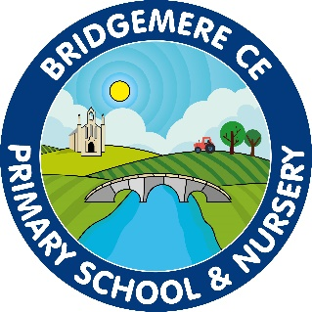
Parent Council Minutes:

Wednesday 10th May 2023

Discussion and Action Points: | Whom/Whe
- Apologies  Attendees  Governor representative  It was noted that we are in need of a parent council representative for Year 1. | GS, NW, EM, NM, EL,  LA, LH, CW, CM(Headteacher)  None  CM to put on another newsletter
- Minutes from last meeting
The minutes were agreed as an accurate narrative of the meeting held on 15th February 2023
- School dates: There was a discussion regarding dates coming up in the summer term. Due to so much going on CM has produced a summer dates newsletter for parents and to go on the website. It was agreed this was useful.  CW asked when the Leaver’s Service would be – CM to add the date and communicate with parents | CM – add Leaver’s service to dates and redistribute
- Clubs were discussed and there was a lot of support for Coach Colin and his Boxing Club early on Tuesday and Thursday morning for KS1 & KS2. The Quidditch that he also runs on a Wednesday after school is well liked by pupils. It was asked if these clubs could continue next year. CM said she would speak to Mr Lyons to ask Coach Colin for his availability. There could be the chance of doing a variety of different sports with is company also. | CM to ask Mr Lyons to co ordinate sports clubs with Coach Colin for September 2023
- LA brought-up Bike Ability and the fact the children have not participated in it this year. CM to look into this for late summer term or September 2023. | CM – ask Mrs Coats to contact Bike Ability for dates
- Parent involvement in school:  All agreed that the opportunity to come into school is beneficial to the children and the parents for communication of the curriculum and between staff and parents.  - Celebration of Learning has been welcomed this year and will be continued – a date needs to be fixed for Summer 2 before the children finish for summer.  - Secret Reader was enjoyed by parents and children and could be repeated  - School lunches – CM discussed parents use to come in and have time with their child to eat a school lunch. Parents were happy for this to happen again. CM said she would speak to School Council to arrange with Mrs Myers the cook.  It was agreed that there should be a further discussion on how best parents can be in touch with school life and the learning of their child. | CM – fix a date for summer term  - Celebration of Learning  - Secret Reader  - Parents to come in for school lunch with their child
Next Meeting
Next Meeting date set for 12th July @ 6:30pm

