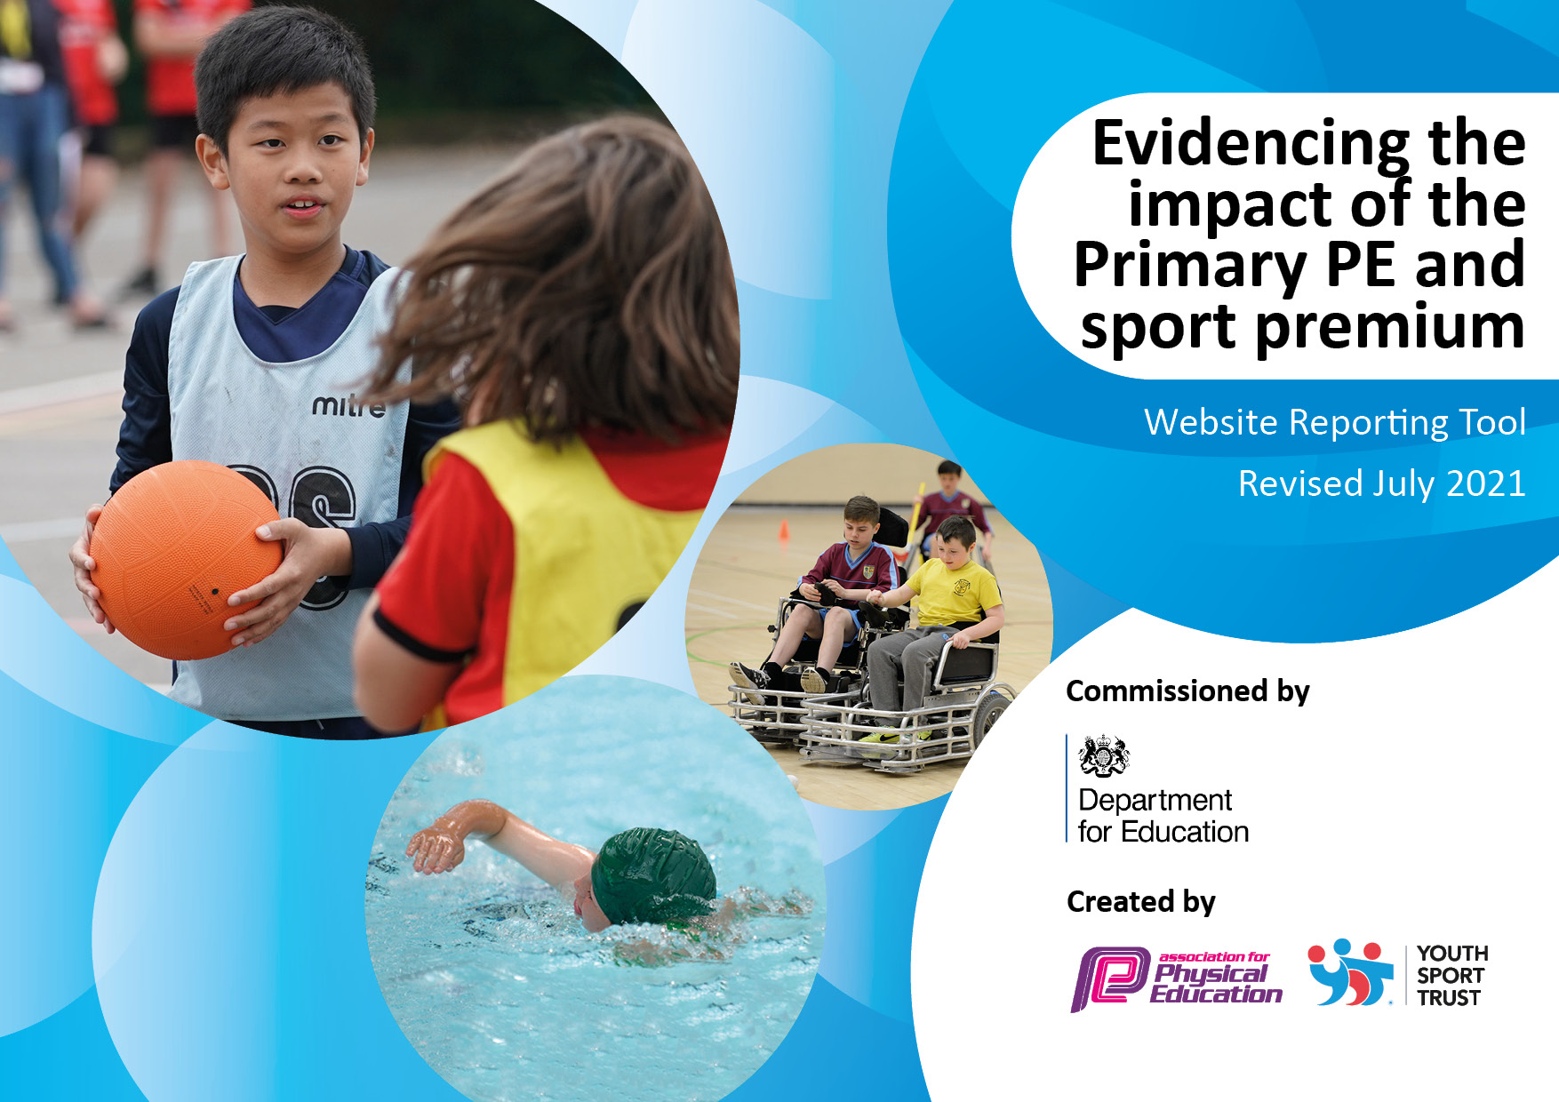
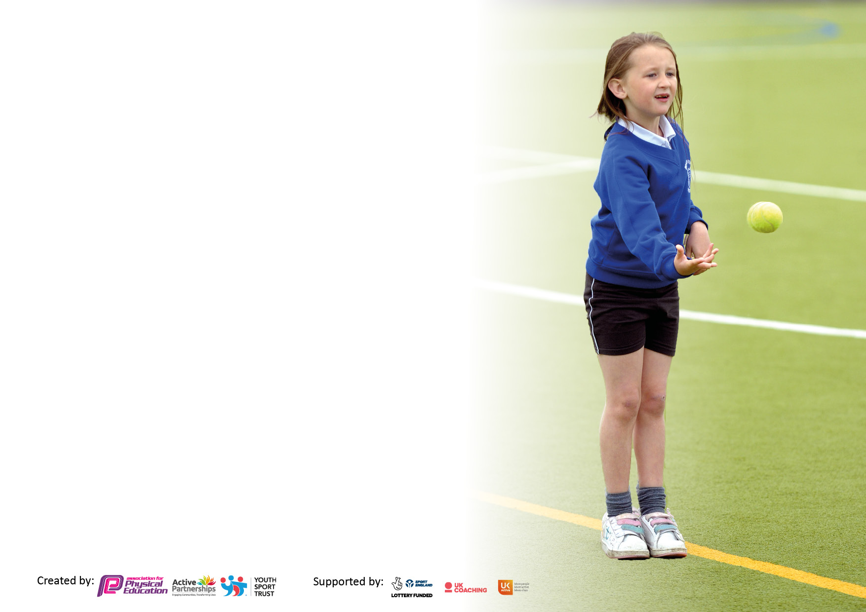

It is important that your grant is used effectively and based on school need. The Education Inspection Framework makes clear there will be a focus on ‘whether leaders and those responsible for governors all understand their respective roles and perform these in a way that enhances the effectiveness of the school’.

Under the Quality of Education Ofsted inspectors consider:
Intent - Curriculum design, coverage and appropriateness
Implementation - Curriculum delivery, Teaching (pedagogy) and Assessment
Impact - Attainment and progress

To assist schools with common transferable language this template has been developed to utilise the same three headings which should make your plans easily transferable between working documents.

Schools must use the funding to make additional and sustainable improvements to the quality of Physical Education, School Sport and Physical Activity (PESSPA) they offer. This means that you should use the Primary PE and sport premium to:

- Develop or add to the PESSPA activities that your school already offer
- Build capacity and capability within the school to ensure that improvements made now will benefit pupils joining the school in future years
- The Primary PE and sport premium should not be used to fund capital spend projects; the school’s budget should fund these.

Pleasevisitgov.ukfortherevisedDfEguidanceincludingthe5keyindicatorsacrosswhichschoolsshoulddemonstrate animprovement.Thisdocumentwillhelpyoutoreviewyourprovisionandtoreportyourspend.DfEencouragesschools to use this template as an effective way of meeting the reporting requirements of the Primary PE and sport premium.

We recommend you start by reflecting on the impact of current provision and reviewing the previous spend.

Schools are required to publish details of how they spend this funding, including any under-spend from 2019/2020, as well as on the impact it has on pupils’ PE and sport participation and attainment. All funding must be spent by 31st July 2023.

We recommend regularly updating the table and publishing it on your website throughout the year. This evidences your ongoing self-evaluation of how you are using the funding to secure maximum, sustainable impact. Final copy must be posted on your website by the end of the academic year and no later than the 31st July 2021. To see an example of how to complete the table please click HERE.
Created by: Supported by:

Details with regard to funding
Please complete the table below.

Total amount carried over from 2021/22 | £0.00
Total amount allocated for 2022/23 | £16,639
How much (if any) do you intend to carry over from this total fund into 2022/23? | £0.00
Total amount allocated for 2022/23 | £16,639
Total amount of funding for 2022/23. To be spent and reported on by 31st July 2023. | £16,639
Swimming Data
Please report on your Swimming Data below.

Meeting national curriculum requirements for swimming and water safety.
N.B. Complete this section to your best ability. For example you might have practised safe self-rescue techniques on dry land which you can then transfer to the pool when school swimming restarts.
Due to exceptional circumstances priority should be given to ensuring that pupils can perform safe self rescue even if they do not fully meet the first two requirements of the NC programme of study
What percentage of your current Year 6 cohort swim competently, confidently and proficiently over a distance of at least 25 metres?  N.B. Even though your pupils may swim in another year please report on their attainment on leaving primary school at the end of the summer term 2023  Please see note above | 92%
What percentage of your current Year 6 cohort use a range of strokes effectively [for example, front crawl, backstroke and breaststroke]?  Please see note above | 75%
What percentage of your current Year 6 cohort perform safe self-rescue in different water-based situations? | 83%
Schools can choose to use the Primary PE and sport premium to provide additional provision for swimming but this must be for activity over and above the national curriculum requirements. Have you used it in this way? | Yes/No  £266

Action Plan and Budget Tracking
Capture your intended annual spend against the 5 key indicators. Clarify the success criteria and evidence of impact that you intend to measure to evaluate for pupils today and for the future.

Academic Year: 2022-23 | Total fund allocated: £16,639 | Date Updated: July 23
Key indicator 1: The engagement of all pupils in regular physical activity – Chief Medical Officers guidelines recommend that primary school pupils undertake at least 30 minutes of physical activity a day in school |  |  |  | Percentage of total allocation:
 |  |  |  | 61%
Intent | Implementation |  | Impact
Your school focus should be clear what you want the pupils to know and be able to do and about  what they need to learn and to  consolidate through practice: | Make sure your actions to achieve are linked to your intentions: | Funding allocated | Evidence of impact: what do pupils now know and what can they now do? What has changed? | Sustainability and suggested next steps:
*Develop playground leaders with UKS2 to encourage a wider range of children to be active.  *Timetable the running track to ensure all children have an opportunity to walk/run around the track at any point of the school day.  *To give all children the opportunity to raise their fitness levels at playtimes/lunchtimes and other points of the day using newly purchased outdoor fitness equipment in order to promote an active lifestyle that children will follow later in life. | - Organise and complete play leader training. Install and implement running track timetable.  - Monthly check of fitness to check children fitness levels.  - Rota for children in all classes to use the equipment  - All children to be taught to use equipment safely. | Provided by CNSSP  Provided by staff  £10,265 | *Children across the whole school have taken part in playground leaders’ games at lunchtime.  *Children have enjoyed team games as part of play leaders.  *Children are using the running track daily and each class have a timetable for when they can use the running track.  *Children are happy to walk or run around the track and are developing a love for running/walking in the outdoors.  *Children are using the outdoor equipment every breaktime/lunchtime. Some classes created a ‘beat my score’ chart to encourage the children to improve their fitness levels and improve on themselves. | - Playground leaders to be trained again next year to ensure new cohort of children are trained.  - Update resources/equipment for playground leaders and set up a rota and register system to monitor participation.  - Monitor participation levels of less active children and begin to give them further opportunities to be active.
Key indicator 2: The profile of PESSPA being raised across the school as a tool for whole school improvement |  |  |  | Percentage of total allocation:
 |  |  |  | 13%
Intent | Implementation |  | Impact
Your school focus should be clear what you want the pupils to know and be able to do and about  what they need to learn and to  consolidate through practice: | Make sure your actions to achieve are linked to your intentions: | Funding allocated: | Evidence of impact: what do pupils now know and what can they now do? What has changed?: | Sustainability and suggested next steps:
*PE subject lead to promote sport and PE throughout the school. To ensure all pupils are provided with the opportunity to take part in a variety of sports and encourage participation in extra-curricular activities provided by external sports coaches.  *Each house team to have their own team captain and vice-captain to encourage and promote sports.  *To encourage active break times by providing a variety of play equipment to engage all children  *Introduce different sports into school to encourage participation from more children in order to foster a love for a sport/active lifestyle.  *Boxing sessions For KS1 an KS2. Morning clubs to develop fundamentals of boxing. Children will develop skills, fitness and engage in a new sport  *To celebrate the achievements of the boxing club and for children to experience a real boxing gym | - Celebrate all sports events in assemblies.  - Website to feature sports events and results.  - Allow external sports coaches to provide after school clubs.  - After every sports topic (half term) children are given the opportunity to represent their house in inter-school competitions based on their learning.  - Team captains voted by pupils. Sports council to decide on what additional equipment is required for break time and lunch time to promote active play. CNSSP to setup playtime leaders with Year 5 & 6 children. To visit the school and demonstrate games for the older children to play with the younger children and build their confidence.  - 45 minute boxing sessions for both KS1 and KS2 weekly on Tuesday and Thursday morning before school.  - Organise boxing trip for children who have engaged with the trip.  - Trip to boxing gym in Northwich. | Provided by PE lead  Sports council to run  £270  £1,445  £530 | *SIP day and positive feedback from school SIP deep dive in PE, identifying curriculum strengths and extra-curricular opportunities for all children.  *Lesson observations and drop ins to check implementation of new curriculum and identify area of CPD to work on.  *Team captains have promoted PE throughout the year during intra-competitions and sports day.  *Children across the whole school have taken part in playground leaders’ games at lunchtime.  *Children have enjoyed team games as part of play leaders.  *All Stars have come in and run many sporting clubs such as quidditch, boxing & pickleball.  *Dance after school club run by TAFPA has been popular with both KS1 and KS2 children.  *Boxing sessions have been very popular every Tuesday morning (KS1) and Thursday morning (KS2).  *Children have learnt the fundamentals of boxing and discipline whilst staying active and keeping fit.  *Children had the experience of going to a real boxing gym and enjoyed the real life experience | - Continue links with All Stars and other external agencies in order to develop a wide range of extra-curricular clubs on offer. Use pupil voice to drive clubs to ensure we are meeting the needs of the children.  - Continue to implement, use and monitor the PE hub planning for all lessons.  - Develop the team captain approach to sports through the school council.

Key indicator 3: Increased confidence, knowledge and skills of all staff in teaching PE and sport |  |  |  | Percentage of total allocation:
 |  |  |  | 13%
Intent | Implementation |  | Impact
Your school focus should be clear | Make sure your actions to | Funding | Evidence of impact: what do | Sustainability and suggested
what you want the pupils to know | achieve are linked to your | allocated: | pupils now know and what | next steps:
and be able to do and about | intentions: |  | can they now do? What has
what they need to learn and to |  |  | changed?:
consolidate through practice:
* Forest School Leader to work in school one afternoon per week for EYFS and KS1  *PE lead to be supported by CNSSP  *Dance CPD led by TAFPA. Weekly sessions for all staff to observe and contribute to the provision of dance teaching in the school. Improve the provision of dance within the school as staff were not confident in delivering.  *New Scheme of work for PE bought in to give teachers a wider range of activities to develop skills. Further develop confidence of a range of sports and activities. To reduce workload of teaching staff. | - Staff to gain knowledge of Forest School activities.  - Staff to be able to implement this within their own lessons to promote more active learning.  - CNSSP in regular communication with PE lead to help develop the curriculum to ensure wide varieties of skills and games  - Opportunities to participate in a range of sporting events for all children.  - TAFPA to attend school in Spring 1. Staff will have the opportunity to learn new knowledge and skills to become more confident in teaching the PE topic independently  - Teachers to engage with lessons and new curriculum planning | See below (Indicator 4)  £400 membership CNSSP  £1,200  £525 | *Development of staff knowledge and understanding of Forest School and OAA.  *Increase the participation of sporting events by going to all four levels of competitions.  * Dance CPD was informative for staff to now teach their own engaging and physical dance sessions using the PEhub scheme of work.  * Teachers have used the new PEhub planning to support the planning and delivery of PE lessons. This has raised the profile of PE and children are more engaged.  *SIP day and positive feedback from school SIP deep dive in PE, identifying curriculum strengths and extra-curricular opportunities for all children.  *Lesson observations & pupil voice have been very positive throughout the year. Workload for teachers has been decreased. | - New member of staff is forest school trained and will run termly forest school sessions once a week.  - Change of subject leader in 2023-2024. Continue to be supported by CNSSP and SLT in school.  - Handover between current PE lead and new lead.
Key indicator 4: Broader experience of a range of sports and activities offered to all pupils |  |  |  | Percentage of total allocation:
 |  |  |  | 5%
Intent | Implementation |  | Impact
Your school focus should be clear | Make sure your actions to | Funding | Evidence of impact: what do | Sustainability and suggested
what you want the pupils to know | achieve are linked to your | allocated: | pupils now know and what | next steps:
and be able to do and about | intentions: |  | can they now do? What has
what they need to learn and to |  |  | changed?:
consolidate through practice:
* Curriculum Map designed by PE lead- ensures broad range of coverage in line with local area competitions for different year groups.  * To introduce a Forest School program which links to the PE curriculum to engage the least active children in achieving their PE objectives in a varied way.  * Milldale for KS2 children to experience OAA and to further widen their experiences with PE. Children will have the opportunity to visit a different site for forest school, team building and personal development. Whilst also developing geographical field work skills.  *Provide pupils with higher quality lessons in swimming (Crewe Swimming)  *Quidditch club start in Summer term to engage non active children in physical activity. Many children enjoy Harry Potter and therefore will engage in these sessions creating the opportunity to develop a positive approach to being physical active. | - Curriculum map designed to fit CNSSP calendar extra-curricular clubs offer opportunities in further sports not offered in curriculum  - Enter a broader range of competitions targeting different children  - To employ a forest school leader to provide 9 weeks of forest school per class and work alongside the teaching staff to embed our curriculum within the sessions (EYFS & KS1).  - To ensure the children are active within the session and promote health and wellbeing.  - For all children in KS2 to attend Milldale. All children to actively take part in all activities whilst at the site.  - KS2 and KS1 to complete 6 week block of swimming.  - Weekly sessions to engage non-active children | Provided by PE lead  £250  £300  £315 | * PEhub Scheme of work has been adapted to fit with the CNSSP competition calendar.  * Curriculum is broad and children enjoy their learning. Evidence from Pupil voice with all classes throughout the year.  * New clubs such as Quidditch and Pickleball are up and coming sports giving children new and exciting sports to try.  * Bridgemere were the first school in England to run a Pickleball club as extra-curricular club.  * Development of staff knowledge and understanding of Forest School and OAA.  - Milldale and Forest school sessions were positive and children were active and developed their geographical fieldwork skills (cross-curricular).  - Quidditch has been an excellent way to get inactive children doing physical activity outside of PE lessons. | - Continue with multi-sport after school clubs.  - Organise the yearly visit to Milldale.  - Continue to offer a broad range of extra curricula clubs for all children using pupil voice as an indicating factor.

Key indicator 5: Increased participation in competitive sport |  |  |  | Percentage of total allocation:
 |  |  |  | 2%
Intent | Implementation |  | Impact
Your school focus should be clear | Make sure your actions to | Funding | Evidence of impact: what do | Sustainability and suggested
what you want the pupils to know | achieve are linked to your | allocated: | pupils now know and what | next steps:
and be able to do and about | intentions: |  | can they now do? What has
what they need to learn and to |  |  | changed?:
consolidate through practice:
* Children in key stage 2 targeted to represent the school in at least one competition against other schools.  * All key stage 2 PE units to end with an intra competition to give all children in the school the opportunity to compete competitively after learning and developing their skills. | - Membership with CNSSP  - Attend as many local level 2 competitions as possible, entering multiple teams wherever manageable.  - At the end of each half term an inter-house competition takes places focusing on the sport that has been delivered during that half term. | CNSSP membership (above)  Teacher led | - Over this academic year, Bridgemere have attended 18 sporting competitions for KS2  - 91% of children in KS2 have represented the school in inter-competitions.  - All children have competed in intra-competitions in school against their rival houses. Putting the skills they learn during PE lessons into practise in a competitive situations. | - Increase participation of competitions in Key Stage 1

Signed off by
Head Teacher: | C.Middleton
Date: | 10/7/23
Subject Leader: | A.Lyons
Date: | 10/7/23
Governor: | E.Ford
Date: | 10/7/23

